Name: Nouman Ghazi
Roll no : Bsai_026
Dynamic Calculator Using If–Else and Loops

Introduction
A dynamic calculator is a program that allows the user to perform multiple arithmetic operations continuously until the user chooses to exit. The calculator uses a while loop to keep the program running and if–else statements to perform different operations based on the user’s choice. It is called dynamic because it allows repeated calculations without restarting the program.

Objectives
• To understand the use of if–else conditions
• To implement loops in Python
• To create a menu-driven program
• To perform basic arithmetic operations

Program Description
1. The program starts with an infinite while loop.
2. A menu is displayed showing arithmetic operations.
3. The user selects an option from the menu.
4. If the user selects Exit, the loop terminates.
5. The user enters two numbers for calculation.
6. If–else statements perform the selected operation.
7. The result is displayed and the menu appears again.

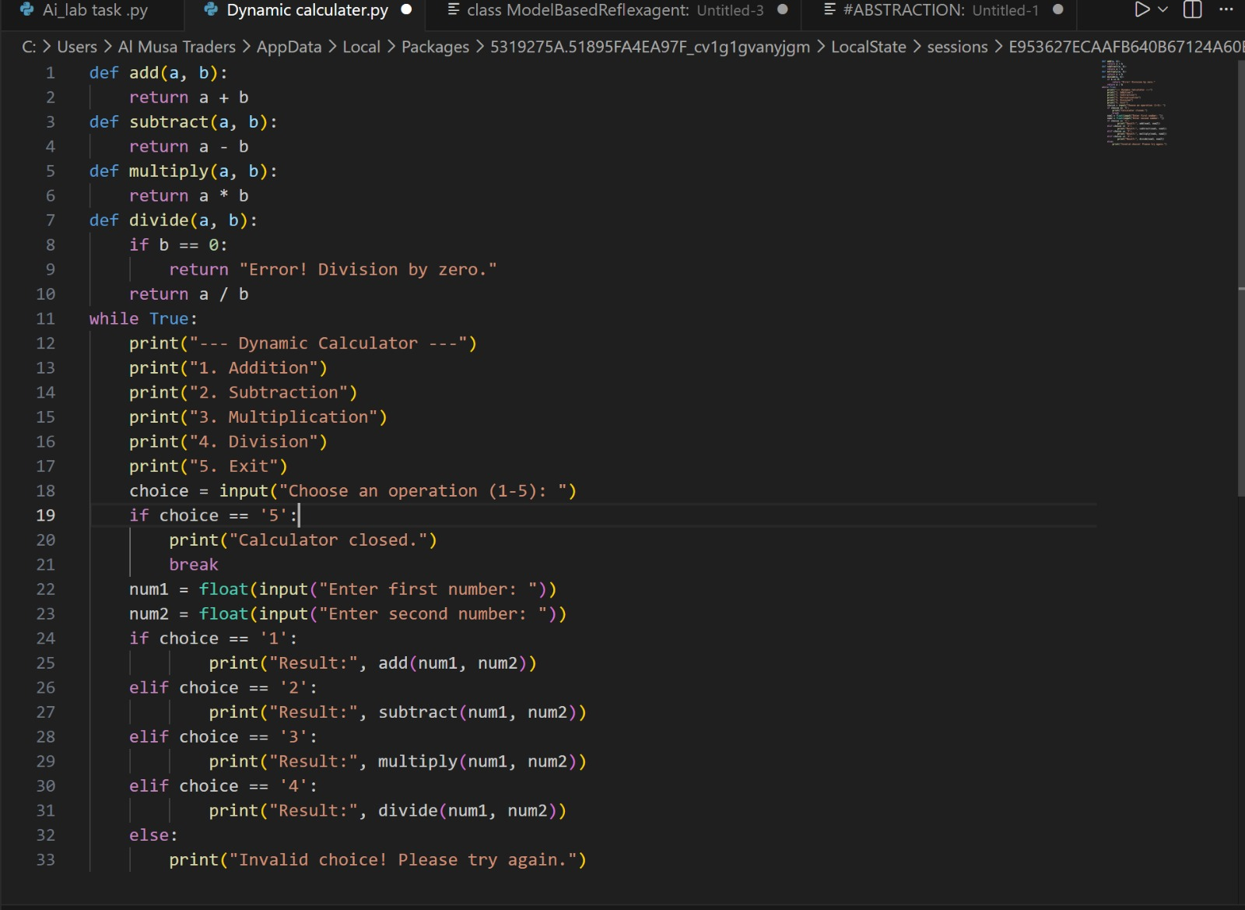
Python Code (Dynamic Calculater)

